1. Start the installation process.

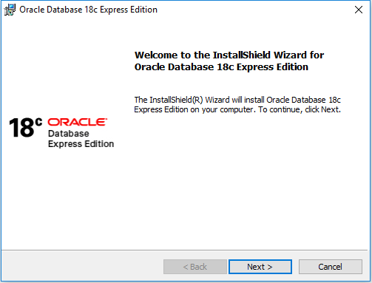

1. Accept terms and conditions.

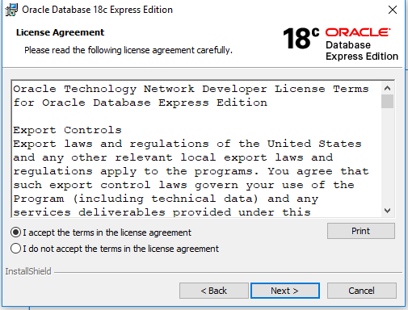

1. Provide destination folder.
2. Set password for your default database.

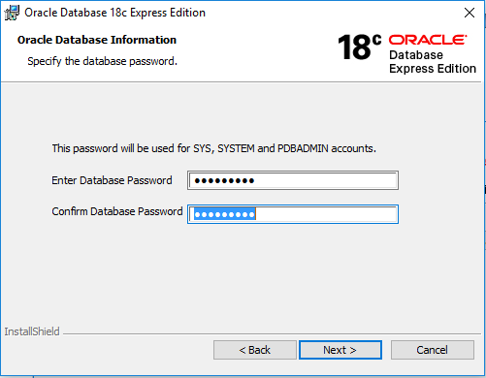

1. Click on install.
2. Installation started.

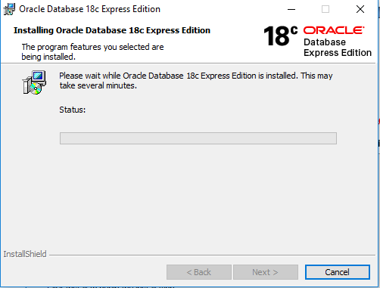

1. Installation completed, Click on finish.

